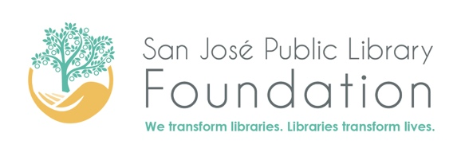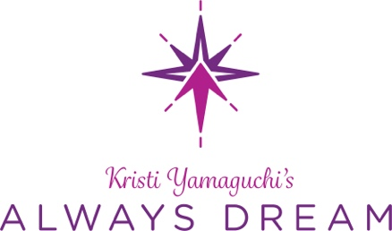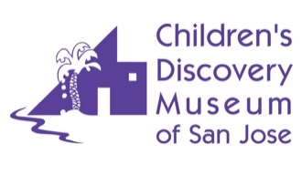

FOR IMMEDIATE RELEASE

CONTACT:
Marly Young, San Jose Public Library Foundation
Marly.young@sjplf.org, 626-524-4693
Cecilia Clark, Children’s Discovery Museum
cclark@cdm.org, 408-221-3814

Bay Area Olympic Gold Medalist Kristi Yamaguchi’s Always Dream, San Jose Public Library Foundation, and Children’s Discovery Museum to Host Inaugural Family Literacy Festival

Event offers celebrity and author story readings as well as family-friendly entertainment

SAN JOSE – Celebrities, Olympic athletes and Grammy award-winning musicians will come together this June 10 for the inaugural Family Literacy Festival hosted by the San José Public Library Foundation, Kristi Yamaguchi’s Always Dream, and Children’s Discovery Museum. The event will feature readings by Olympic Gold Medalist Kristi Yamaguchi, U.S. Silver Figure Skating Champion Polina Edmunds, Olympic Bronze Medalists Maia and Alex Shibutani (ShibSibs) and children’s book authors New York Times bestselling author Jennifer Fosberry, Tim McCanna, and Maggie Tokuda Hall, as well as performances from Grammy-winners Alphabet Rockers and children’s musician AndyZ.
The event is the brainchild of Olympic Gold Medalist, mother, and children’s book author Kristi Yamaguchi who established Always Dream to increase early childhood literacy rates among underserved communities. “By collaborating with Children’s Discovery Museum and the San Jose Public Library Foundation, we can align our resources and create a day-long celebration highlighting the importance of literacy in a fun, interactive environment, it’s all about the power of one,” she said.

The festival will take place at Children’s Discovery Museum located at 180 Woz Way, San Jose, CA 95110 on June 10 from 9:30 a.m.- 12:30 p.m. for the morning session or 1:30 p.m.- 4:30 p.m. for the afternoon session. Tickets can be purchased in advance online or at the door on June 10.

“We know from decades of research that reading to children opens the door to a brighter future by improving academic performance and supporting brain development. The San Jose Public Library Foundation is thrilled to co-host the Family Literacy Festival and hopes it will inspire more families to discover the joys and immense benefits of reading together. It’s going to be a terrific event,” said Dawn Coppin, chief executive officer of the San Jose Public Library Foundation.

Families will be able to enjoy all the Museum has to offer along with celebrity and author story readings, hands-on activities and art projects, and family-friendly entertainment. In addition, there will be an interactive Mobile Learning Adventure sponsored by PNC Bank in the museum's West Wing Gallery showing parents the importance of early childhood education, while they and their children engage in fun activities that explore future occupations, including costumes, passports, and a photo booth.

“Literacy is so essential for children to succeed in school and life,” said Marilee Jennings, executive director of Children’s Discovery Museum of San Jose. “The Always Dream and San Jose Public Library Foundation have both transformed the lives of many young readers, especially those from disadvantaged families, a community that the museum cares deeply about. Kristi and the San Jose Public Library Foundation have been friends of the museum for many years - we’re proud to partner with them to open more doors for more children."

Capacity is limited so interested families should reserve their spot now.

Always Dream: Kristi Yamaguchi’s Always Dream ensures children and families from underserved communities have access to high-quality books in the home environment and extensive family engagement support.

San Jose Public Library Foundation: The San José Public Library Foundation provides advocacy, financial support, and leadership to San Jose public libraries and educational programs throughout the city to create an educated, equitable, and engaged community.

Children’s Discovery Museum: Kids lead the way at Children’s Discovery Museum of San Jose, exploring and discovering through open-ended, play-based learning. Over 150 hands-on exhibits and programs in the sciences, humanities, the arts, nature, and health spark curiosity and ignite family fun where children build life skills in creative and critical thinking, problem solving, and confidence.

###

